Resources to Dream

Vendor Application

Applicant Information
Full Name: |  |  |  | Date:
 | Last | First | M.I.

Address:
 | Street Address | Apartment/Unit #

 | City | State | ZIP Code

Phone: |  | Email

Description:

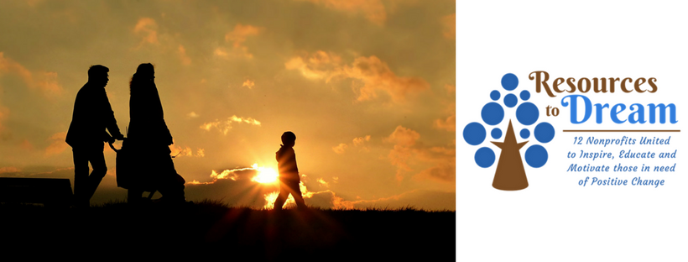
MISSION: An incubator of hope that aids in bringing forth an impartation of knowledge that will not entertain issues of life and to never invest in anything we are not willing to learn about

Refresh, Refill, Renew is a day conference created to draw you closer to the Lord.
It is designed to encourage all who attend to continue their God given assignments with a focus on receiving the necessary tools to deepen their relationship with Him. Every attendee will learn how to renew their minds through God's word and experience His way of R.E.S.T.
Each one who enters the doors will receive practical tools on how to breathe by refilling the physical body to renew and energize one's spirit.
Agenda:
*Nourishing the Relationship with our Father
*Reinforced Time with our Father

DEADLINE FOR SERIUS VENDORS MUST BE PAID BY RECEIPT FIRST COME FIRST SERVED ON OR BEFORE AUGUST 1ST. 2019. OR YOU WILL BE SUBJECT TO PAYING A LATE FEE IN THE AMOUNT OF $10. The event is seat specific where we are looking for specialty services from the following consultants (DoTerra, Scentsy, Holistic Soaps, Body Lotions and Candles). In the event you have any questions, please email them to us we are here to help. Breakfast, lunch and materials are included with your vendor registration package. The menu has not been determined if you have any dietary exclusions please email them with your application.

Reg. Vendor Rate |  | Fundraising Rate | Chair & table | Program/advertisement | Lunch
$100 |  | n/a | n/a | n/a | n/a
Total:

Venue: Dream Center
Address: 4501 Spring Forest Rd. (Off of Capital Blvd.)
Date: September. 07 2019
Time: 10:00 am to 2:00 pm

Email: application to resourcestodream@gmail.com
Make payment to: Pay A Heart After the Father LLC. Pay Pal.Me

I certify that my answers are true and complete to the best of my knowledge. I also allow RTD consent to take pictures and videos for the purpose of research & developmental purposes and advertisement for future events. I understand that all fees paid are refundable (two weeks prior to date to fill vacancy) no exceptions. Thus, the participant can and will be selected to participate in a future event hosted by RTD.
Signature: |  | Date:

